Rogue Quest

Level Editor

# Modes

## Add / Delete Mode

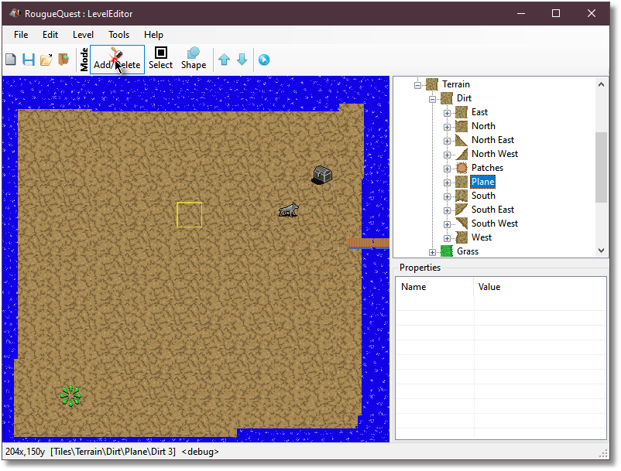

When in **add/delete** mode, you can **left-click with the mouse** to add a single tile of the type selected in the materials browser.

If you have a folder selected instead of a single tile then the editor will use a random tile from the folder. This is useful when drawing plains such as dirt, grass and ocean because it will create a non-uniform plain and look more natural.

**Dragging with the left mouse button** down will “paint” with the selected material.

**Clicking with the right-mouse button** will delete the highlighted tile, while **dragging with the right mouse button** delete all tiles that the mouse hovers over acting like an eraser brush.

## Select mode

# 

When in select mode you can **single left click the mouse** to select a single tile and then left click drag it.

With the **right mouse button**, you can drag to select multiple tiles.

Holding the **shift** key while dragging the right mouse button or while single clicking the **right mouse button** allows you to add more sections to the selected tiles.

Holding the **control** key while dragging the right mouse button or while single clicking the **right mouse button** allows you to remove more sections to the selected tiles.

Once you have the desired tiles selected, you can **left click them with the mouse** to drag them to a new location.

**Left or right mouse clicking** anywhere else on the map without holding **shift** or **control** will deselect all selected tiles, as will changing the mode.

You can also use the keyboard to modify the selected tiles. The **up**, **down**, **left** and **right** keys will move the selected tiles one pixel in the respective direction and the **delete** key will delete the selected tiles.

## Shape Mode

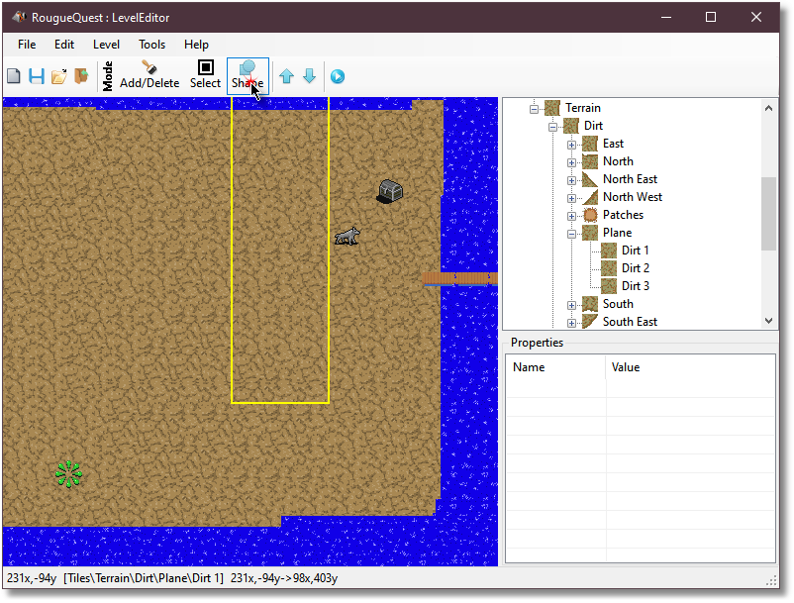

Shape mode allows you to flood fill the selected tiles using the **left mouse button** or flood delete using the **right mouse button**.

# Special Tiles

## Spawn Points

Each level requires a spawn point. The spawn point is where the player will appear when they enter the level.

There are three colors of spawn points but they are all the same, the colors are provided for contrast purposes on whatever terrain you want to place them. These spawn points are not visible when playing in game.

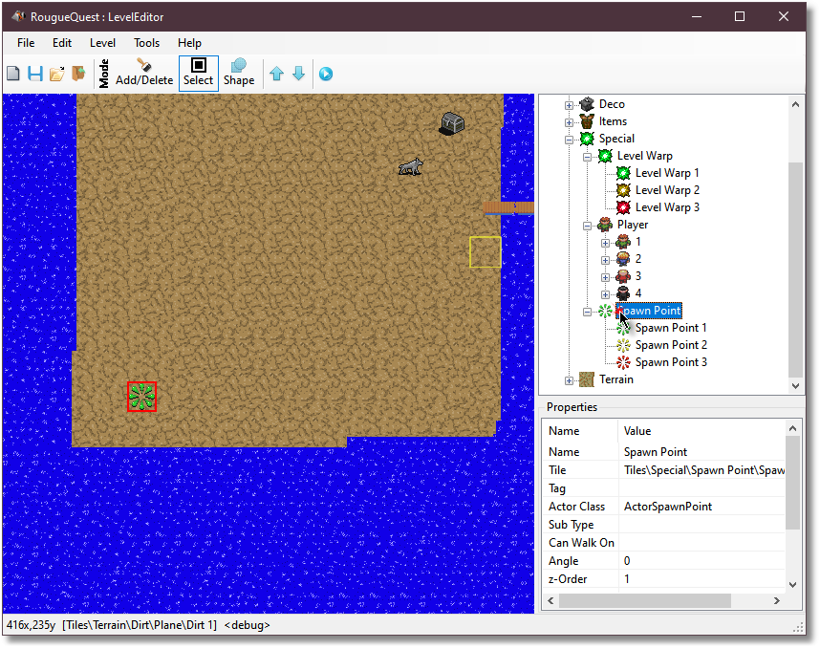

## Level Warps

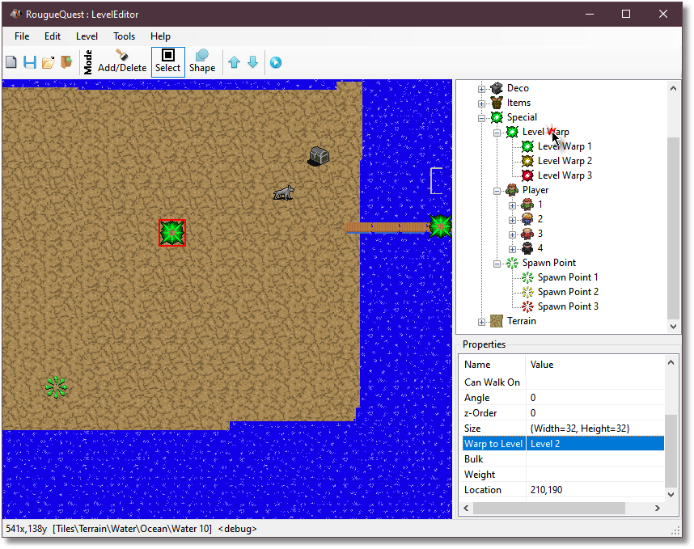

Level warps are used to send the player to another level in the game. There are three colors of warps but they are all the same, the colors are provided for contrast purposes on whatever terrain you want to place them. These warps are not visible when playing in game.

After placing a warp, you can select it using the selection mode then **double left click** on it with the **mouse** to bring up the level selection screen. When the player intersects this tile in game, they will be instantly warped to the selected level.